Week 8 Content assignment info (600 words)

**Page one: Home page**

Welcome to Blake Torres Designs! We are an independently owned, fine woodworking company that highlights the beautiful designs of our designer Blake Torres and the quality of woodworking that he is best known for. No project is too big or too small, and we value quality work and design. Please let this page be a tool to familiarize yourself with our versatility and capabilities. We want to give you the best experience possible when it comes to your design wants and expectations. Quality and satisfaction is our main priority here at Blake Torres Designs. We are open to answering any questions you may have about woodworking and the steps that go into it for your next project. We want you, the customer, to come to us with any questions you might have. Please contact Monday through Friday from 8 am to 6 pm central standard time. We would love to hear from you and get your thoughts about placing an order with us today. You can reach us by phone at 409-719-8927 or by email at blaketorres2000@gmail.com. We are excited and look forward to hearing from you.

**Page two: Gallery**

Please take some time to look at some of the products and designs that we have produced here at Blake Torres Designs. We want you to be able to see some of our finished products and the quality of our designer's work. We want this gallery to give you an up-close look at our products and what we are capable of achieving here at our company. We hope that you are able to see the versatility and attention to detail that we value. Our hope is that this arrangement of photos is easy for you to see the craftsmanship that goes into each of our custom builds. Some of these photos highlight our woodworking designs from the shop setting to the final placement settings. Giving you the full array of the woodworking process and experience.

**Page three: About Blake**

Just a little bit about our designer, Blake Torres. He was born and raised in Texas. He values family and friend relationships. He is a family man, and his greatest joy comes from being with his family. He first started working with wood projects in his early twenties as he built little things for family and friends. He ultimately fell in love with woodworking from those early projects and has a great passion still to this day for it. Blake has an eye for design and detail. He loves working with people and coming up with new and exciting projects to build and create. Blake's favorite projects and designs are the ones that bring families closer together, whether it is a kitchen table or a beautiful custom picture frame, he loves the joy that these things bring to his customers and their families. When it comes to woodworking, he values quality work and customer satisfaction above all else. Blake loves every step of woodworking. He can often be found at his sawmill cutting up tree logs and turning them into workable slabs of lumber for his future projects. He states that being involved from the earliest start allows him to admire what it is that he has designed and where it all started from. Seeing a project from start to finish is something he will never tire of. He has great hopes that his love of woodworking and design will influence those around him to want to do the same. Being able to build and create something beautiful out of nothing is a remarkable feeling of accomplishment, and he wants to pass that excitement on to others so that they can experience the same feeling of accomplishment that he does.

**Images for home page:** 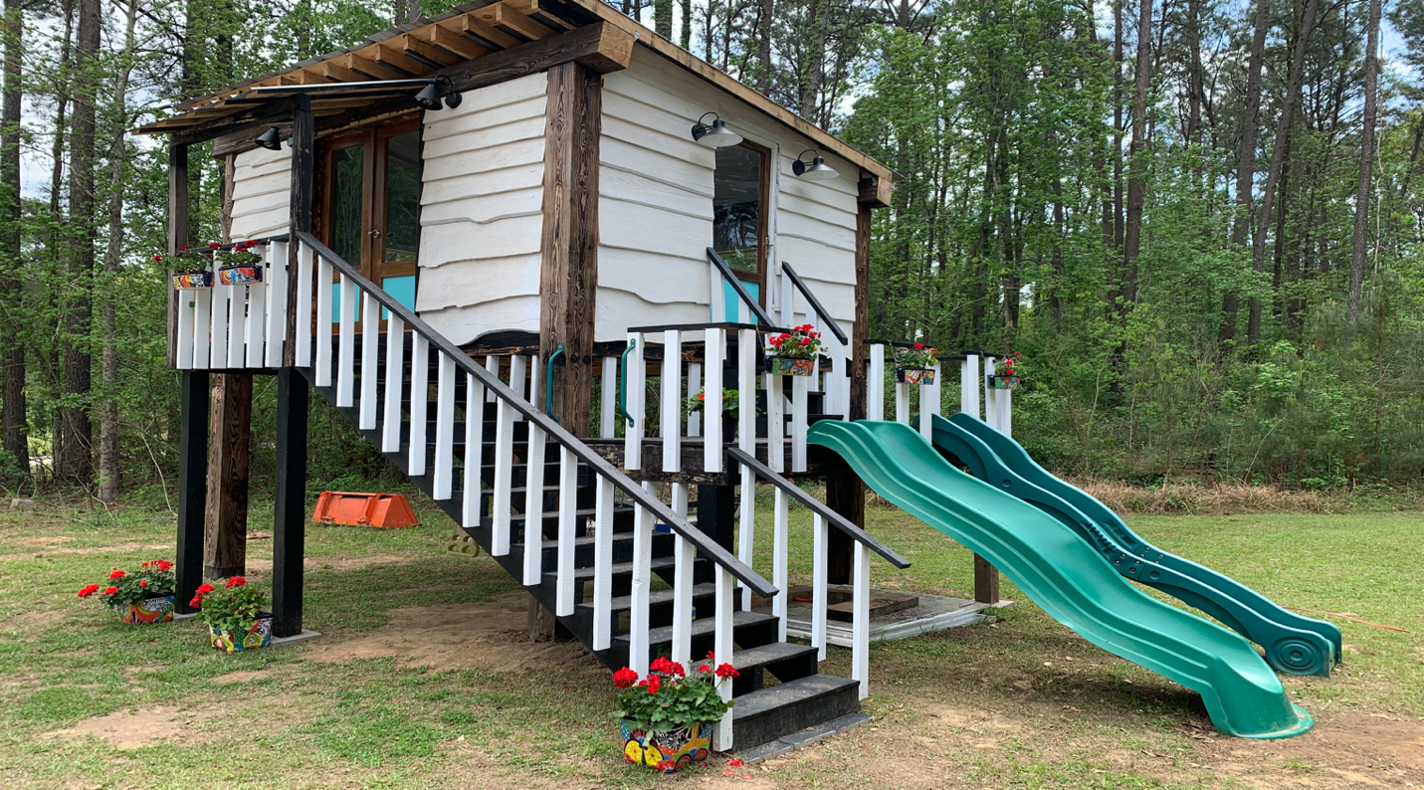

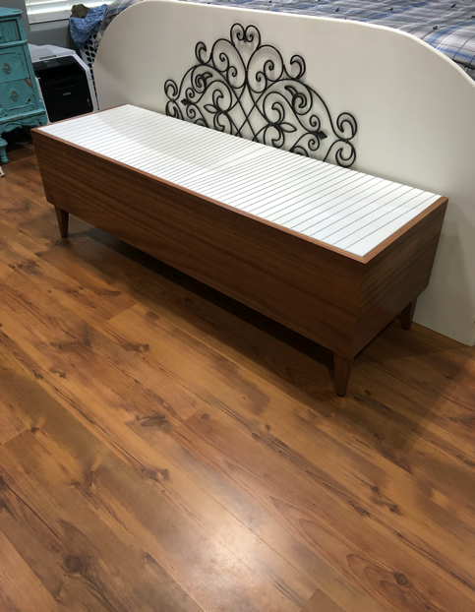 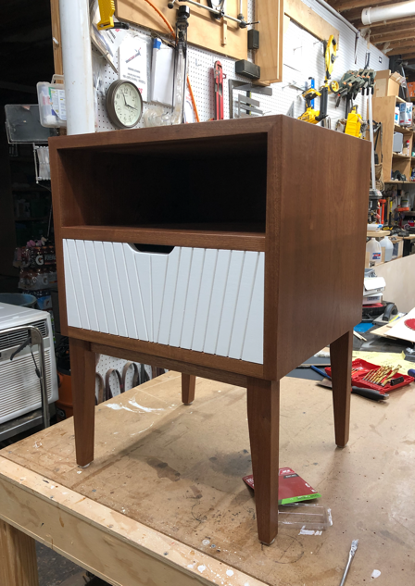 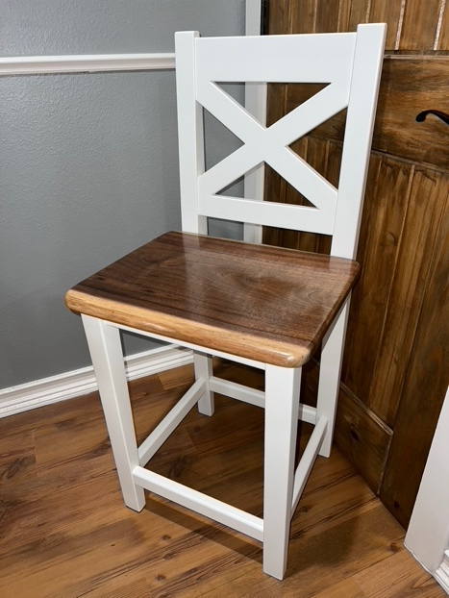

**Images for gallery**:

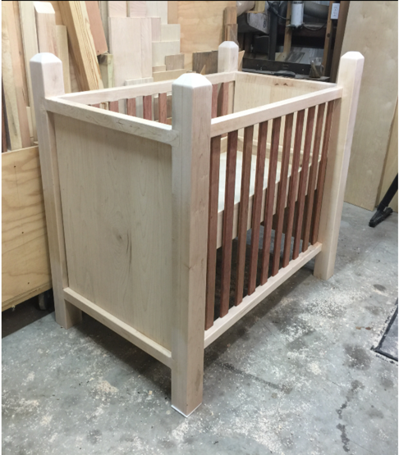 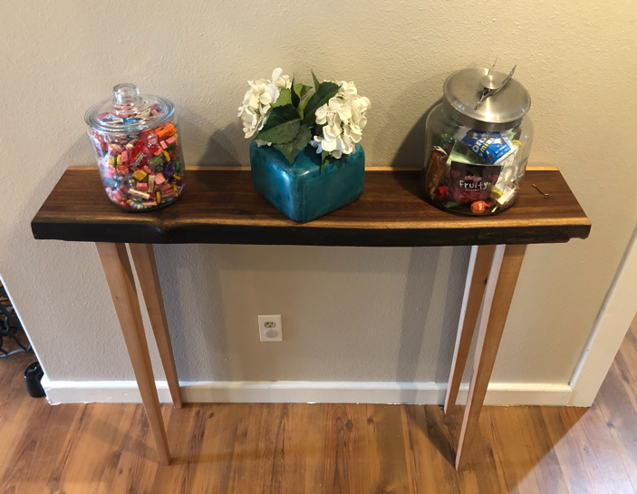

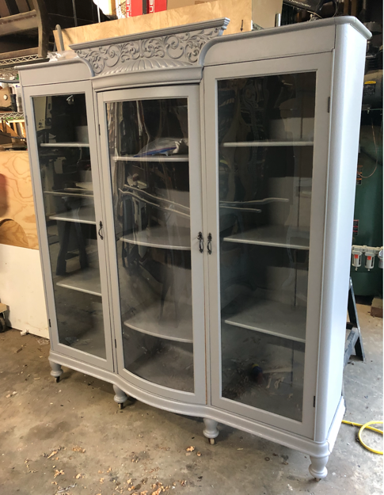 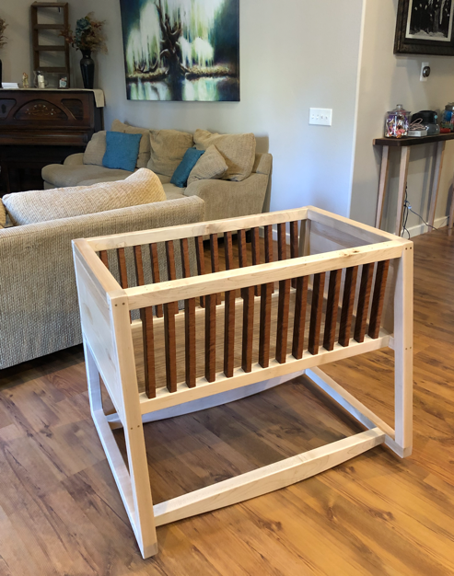 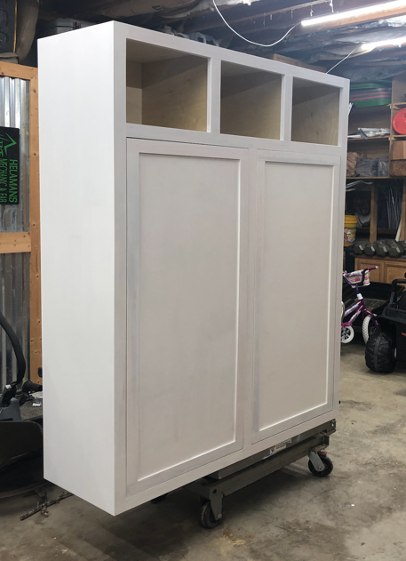

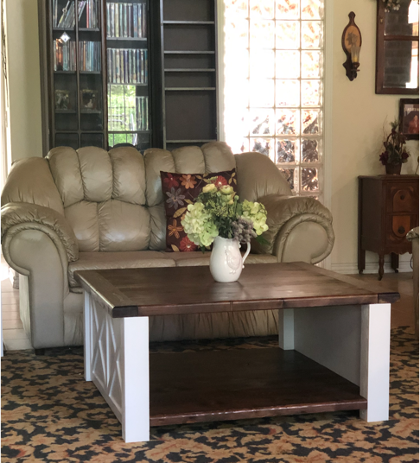 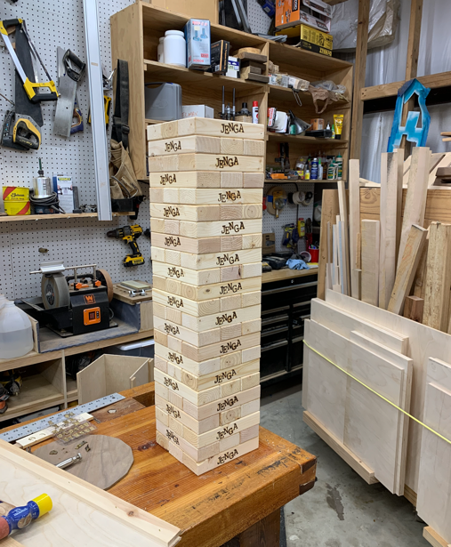 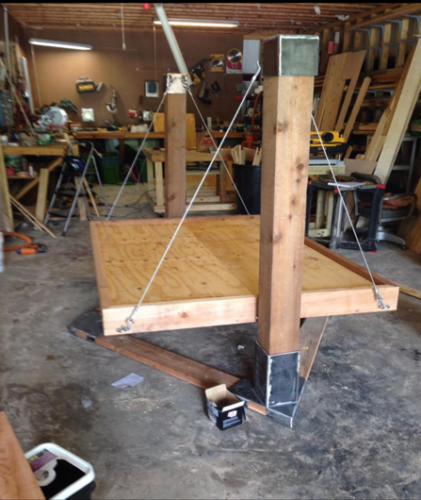

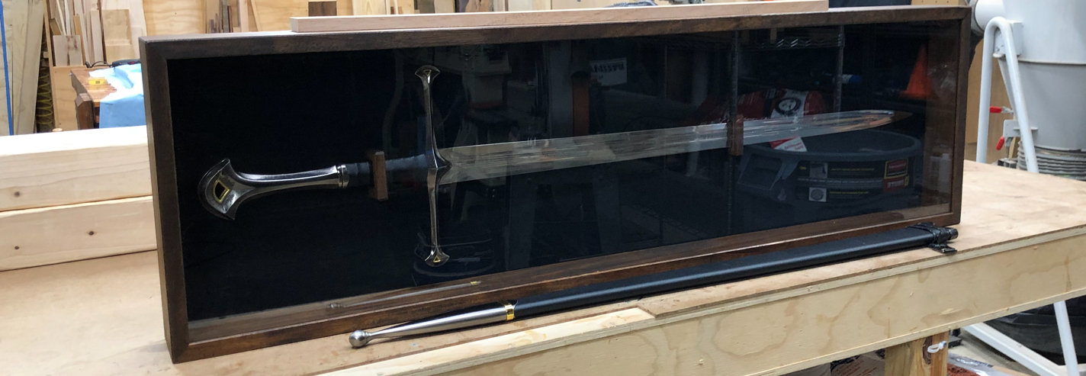

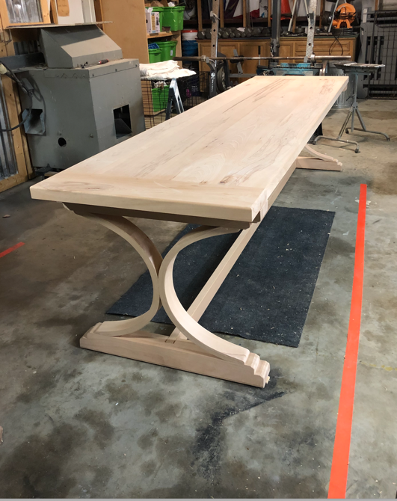 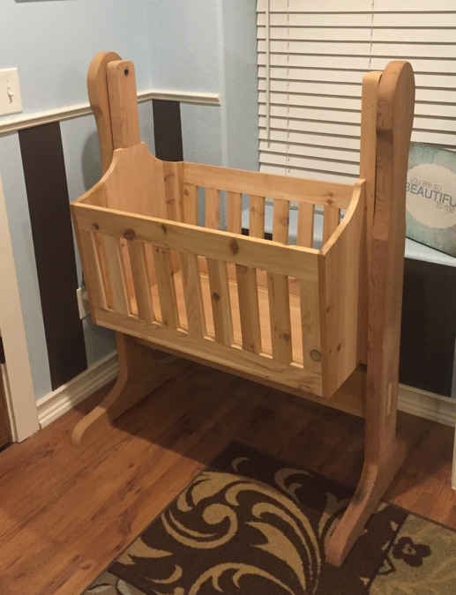 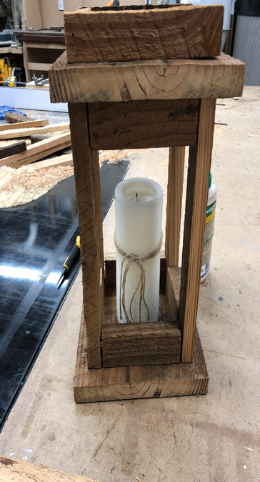

**Images for About Blake:**

